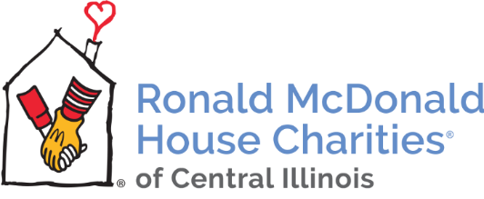
MEDIA ALERT
Peoria Ronald McDonald House Receives $3.3 Million Gift
AbbVie Announces $100 Million Donation to Ronald McDonald House Charities
August 20, 2018 – Peoria, IL – Today, AbbVie, a research-based global biopharmaceutical company, announced a donation of $100 million to Ronald McDonald House Charities (RMHC). This donation, the largest single gift in RMHC’s history, will be used to build family-centered spaces and more than 600 new guest sleeping rooms at 32 Ronald McDonald Houses the United States. The Peoria Ronald McDonald House was selected as one of the 32 houses and will receive $3.3 million to go toward the overall $7 million build cost of the new Peoria House.
“We are extremely pleased and grateful for this gift,” said Kelly Thompson, Chief Executive Officer of Ronald McDonald House Charities of Central Illinois. “It’s wonderful to be able to announce it and celebrate with the community.”
“We would not be able to build the House here in Peoria if not for this gift and the ongoing support from our local community and corporate sponsors – Farnsworth Group, River City Construction, The Dax Foundation, CEFCU, Blue Cross and Blue Shield of Illinois, Marquis Energy, McDaniels Marketing and McDonald’s Owners/Operators of the central Illinois region,” stated Thompson. “Having this gift in hand means we can now move forward with our groundbreaking next month and shift our focus to the final $1.5 million needed to be raised to complete the project,” she added.
The new four-story Peoria Ronald McDonald House will be located on the corner of Spalding Avenue and NE Monroe Street and will serve over 700 families annually and provide hundreds of volunteer opportunities for the community as well as a dozen or more new jobs.
Additional information about the donation from AbbVie is available online. To learn more about the Peoria Ronald McDonald House, please contact Kelly Thompson, CEO of Ronald McDonald House Charities of Central Illinois, at 309-401-2525 or kt@rmhc-centralillinois.org.

About AbbVie
AbbVie is a global, research and development-based biopharmaceutical company committed to developing innovative advanced therapies for some of the world’s most complex and critical conditions. The company’s mission is to use its expertise, dedicated people and unique approach to innovation to markedly improve treatments across four primary therapeutic areas: immunology, oncology, virology and neuroscience. In more than 75 countries, AbbVie employees are working every day to advance health solutions for people around the world. For more information about AbbVie, please visit us at www.abbvie.com. Follow @abbvie on Twitter, Facebook or LinkedIn.
About Ronald McDonald House Charities of Central Illinois
Ronald McDonald House Charities of Central Illinois is a non-profit 501(c)(3) organization whose mission is to provide a supportive place for families to stay while their child is receiving medical care and supports programs that directly improve the health and well-being of children. We provide families with private bedroom and bathroom, home-cooked meals and more to help ease the stress they face during a medical crisis. For more information, visit rmhc-centralillinois.org, follow RMHCCI on Twitter (@RMHCCI) or on Facebook.

Media Contact:
Kelly Thompson, RMHC of Central Illinois
Chief Executive Officer
kt@rmhc-centralillinois.org
309-401-2525

Elizabeth Allen, McDaniels Marketing
Public Relations Director
eallen@mcdmarketing.com
309-346-0512

